AC/DC TROOPER KISS APRIL WINE NAZARETH JUDAS PRIEST WHITE SNAKE CINDERELLA

BEST COVERS ON THE PLANET

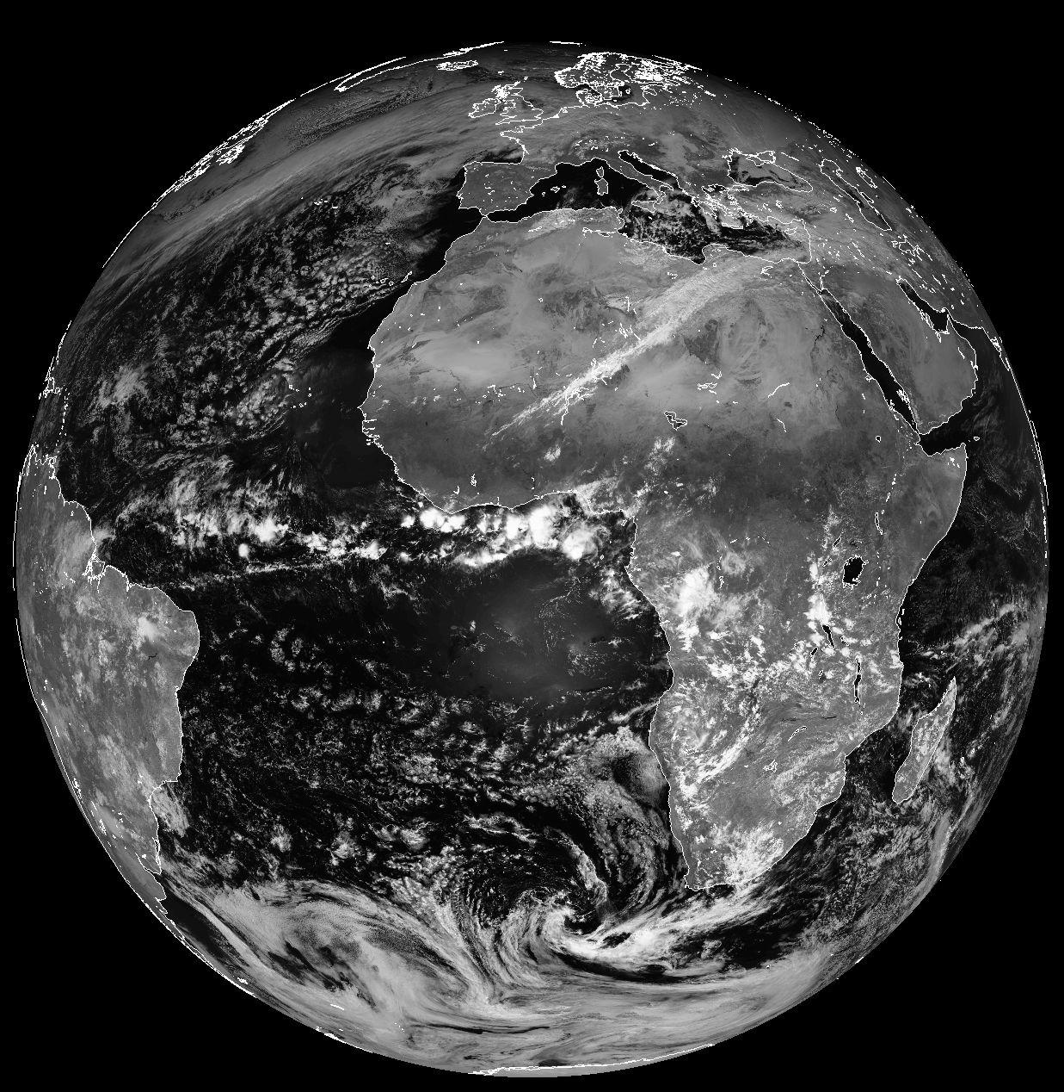

MA MILLERS PRESENTS

SATURDAY APRIL 2nd 2011

***SPLIT2ND***

MA MILLERS

2903 SOOKE LAKE RD

LANGFORD, BC *FREE ADMISSION*