[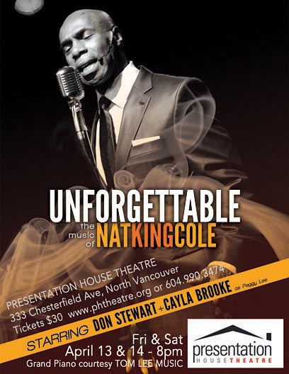](http://www.donstewart.ca/)